Instruction for Authors

Taro Kyoto ⁽¹⁾ and Hanako kyoto ⁽²⁾
(1) Faculty of Medical and Biological Engineering,
Biological Engineering University
(2) Graduate School of Biomagnetism, Biological Engineering University

Abstract The abstract with about 150 words should be presented here. It is preferable that all authors write the abstract of the proceedings paper in English.
Keywords Paper format, Medical and Biological Engineering, Biomagnetism and Bioelectromagnetics

1. Introduction
Your manuscript should be the camera-ready master for the offset printing of the paper ^{[1]}. Based on this Instruction for Authors, please submit your manuscript in two or three pages with figures, photos, and tables pasted onto the document and the layout complete.

2. Size of the manuscript
Create your document on an A4-size sheet. Two or three pages is allocated for each manuscript. Leave 35 mm margin for top and bottom, 20 mm for right and left. Create your document inside the margin; please do not write in the margin.

3. Format
(1) Please write in the following order.
In the first line, title (font type Times New Roman, Bold style, size 16pt); in the second line, authors and organization in English (font type Times New Roman, size 14pt). Please indicate all affiliations with a superscript number immediately after the author's name and in front of the appropriate address.
(2) Please use 10.5pt Times New Roman and a double-column format. Line space may be adjusted as appropriate.
(3) Head each section with numbered titles (font type Times New Roman, Bold style, size 10.5 pt) such as 1. Introduction, 2. Materials and Methods, 3. Results, 4. Discussion, and so on, for your paper to be easily comprehensible.
4. Figures, Photos, and Tables
Please use a clear image. All pages can contain color figures and tables. Please put captions at the bottom for a figure or a photo, and on the top for a table. Indicate reference with suffix ^{[1]} in the main text and a list of reference at the end of the paper in the manner shown on this page.

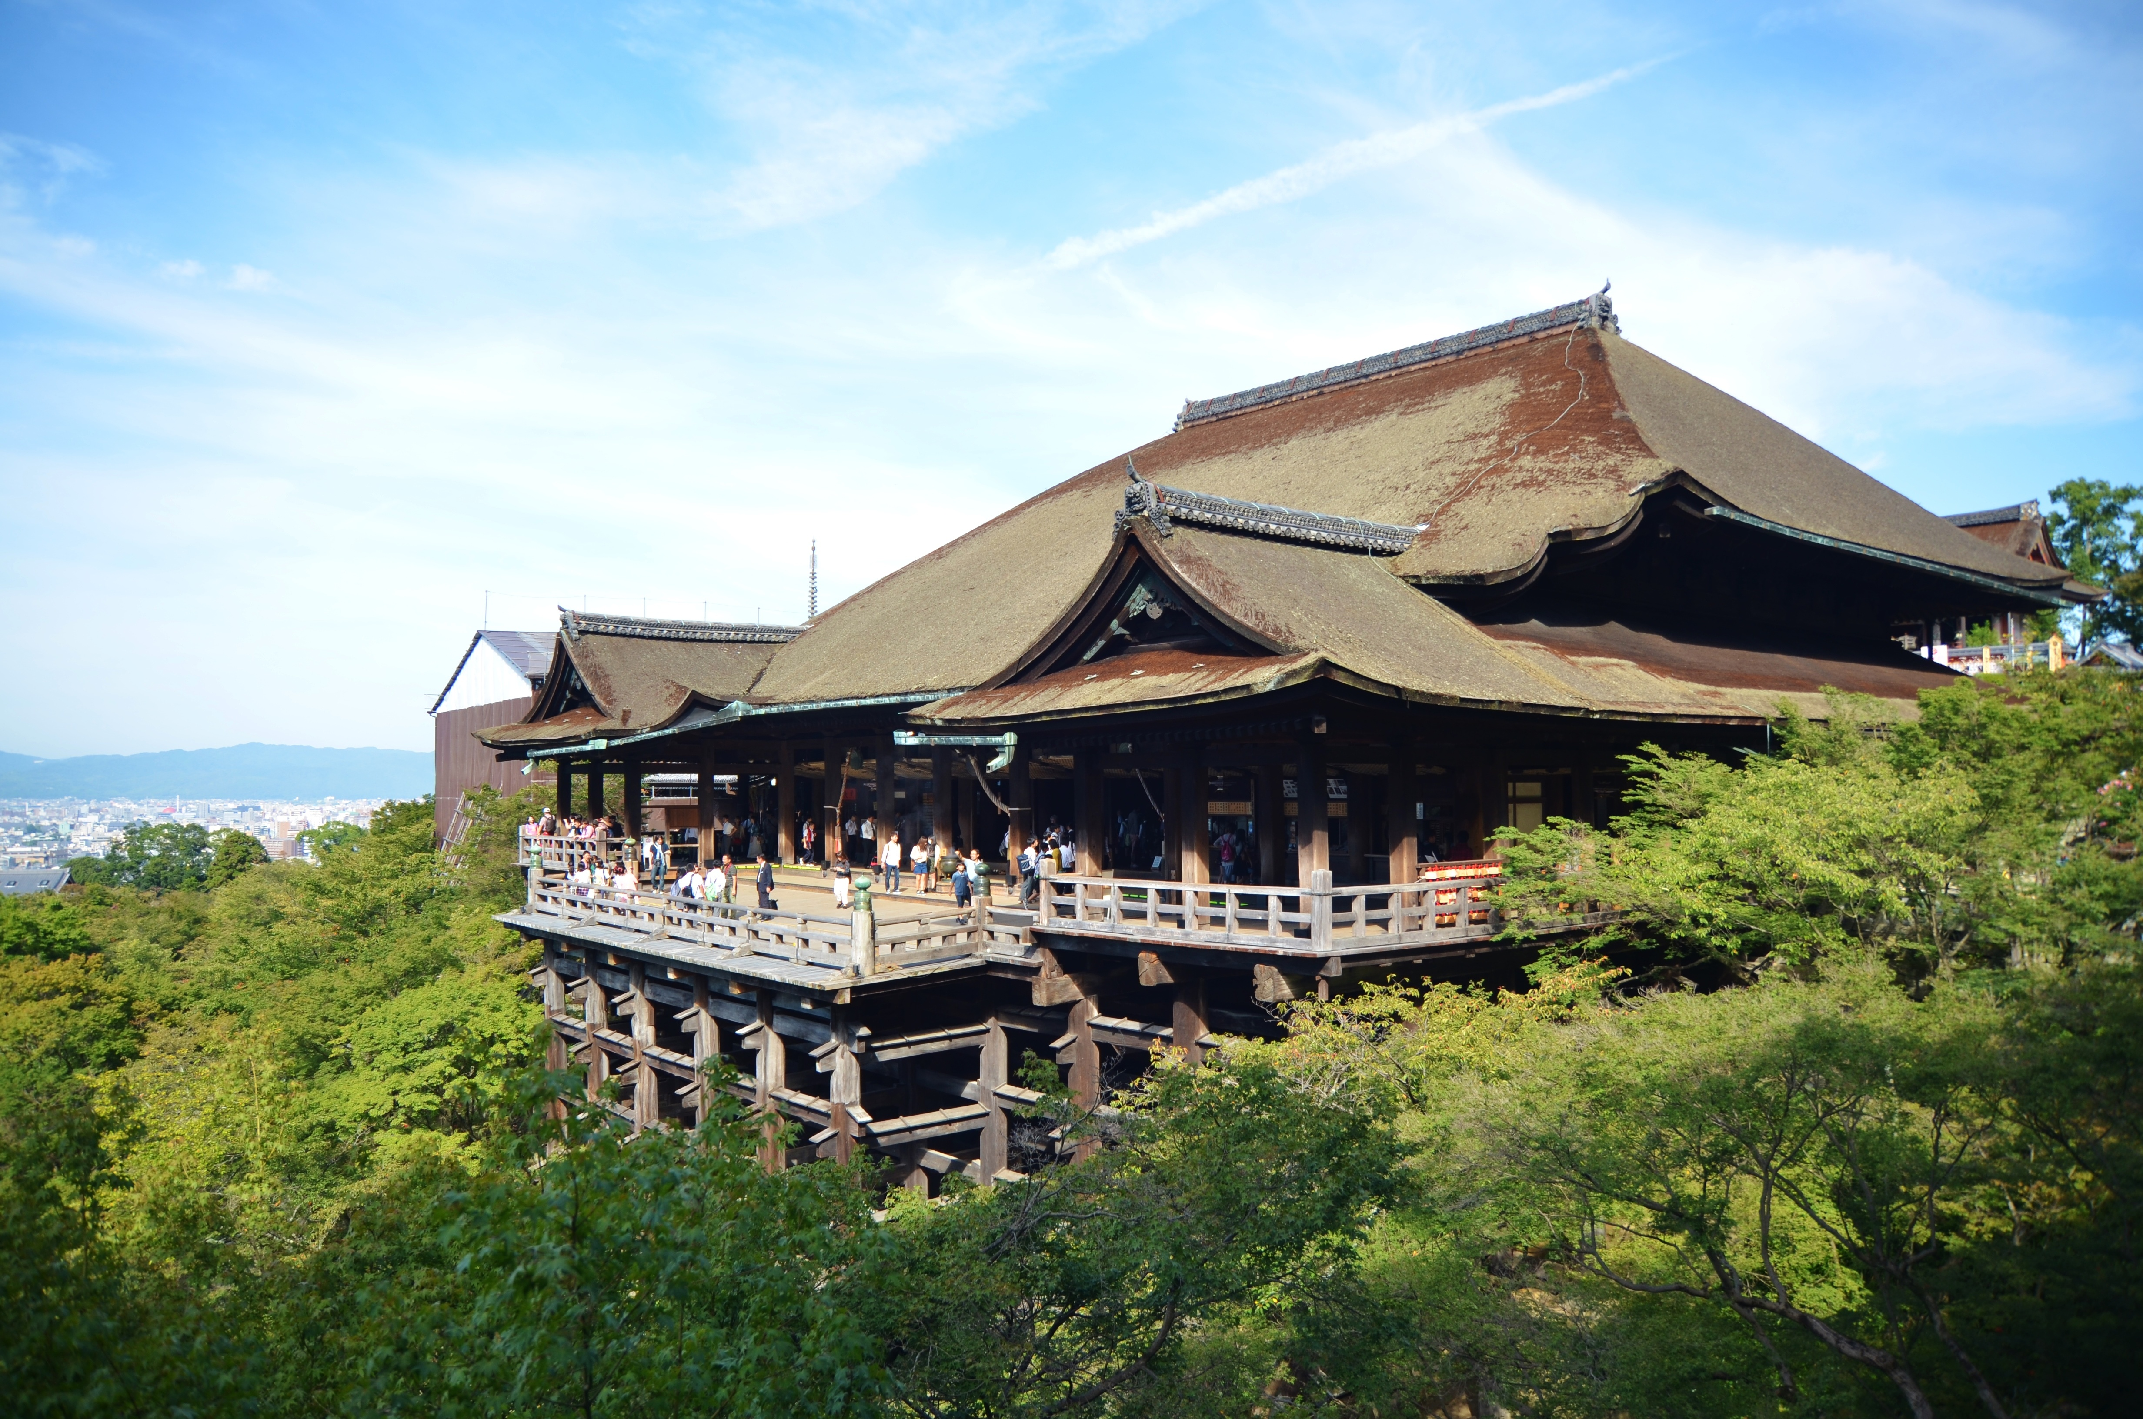
Fig. 1. Kiyomizu-dera Temple.

5. Sending the manuscript
Manuscripts should be uploaded in Adobe PDF format.

Deadline: April 16, 2021

References
[1] Kyoto T, Kyoto H. (2020) Instruction for authors. J. Biol. Eng. Soc. 20:1-10.
[2] Kyoto T, Kyoto H, Kyoto K et al. (2020) Recent advantages in biological engineering. J. Biol. Eng. 999:999-9999.

When you can publish your contact email, please write it at the end.

Taro Kyoto: kyoto@taro.ac.jp

